Constructing Perpendicular Line

Definition
# Source: AI Source: Provided by: [Data Path: Persons Table -> ID Column: 1, Name_En Column: Motasem Essam] -> From: [ChatGPT] on [7/25/2026]
Constructing a perpendicular line is a geometric construction in which a line is created so that it intersects a given line at a right angle.
If lines $l_{1}$and $l_{2}$are perpendicular, then:
$$\boxed{l_{1}⊥l_{2}}$$
and their angle of intersection is:
$$\boxed{{90}^{∘}}$$
A perpendicular line can be constructed through a point on a given line or through a point outside a given line.
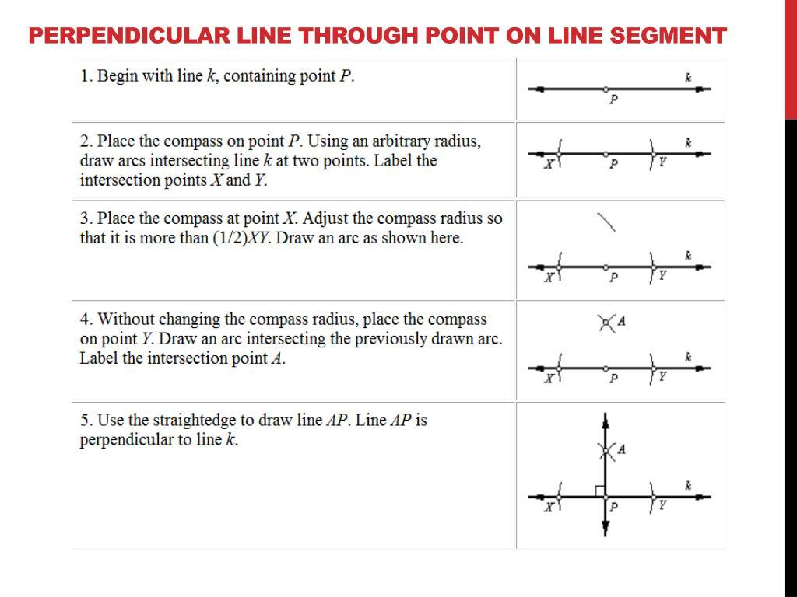
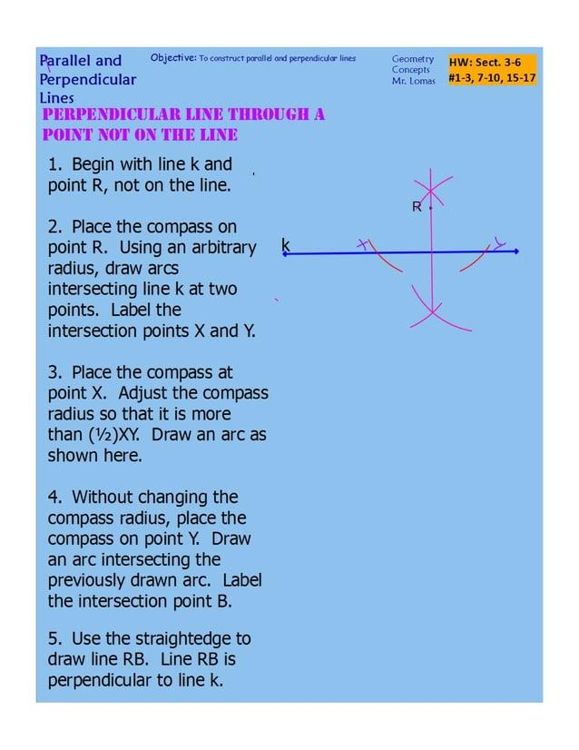
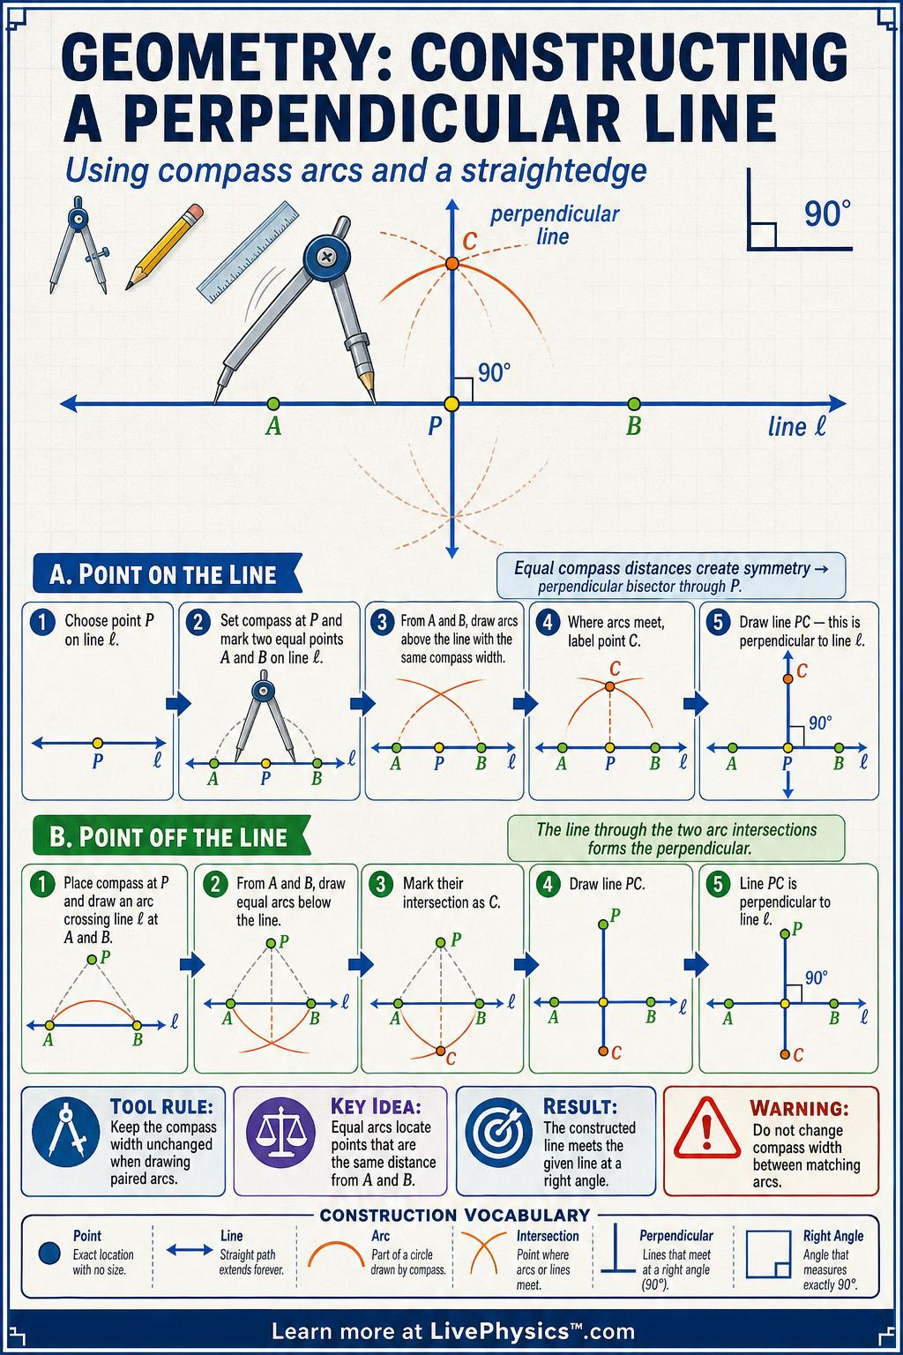
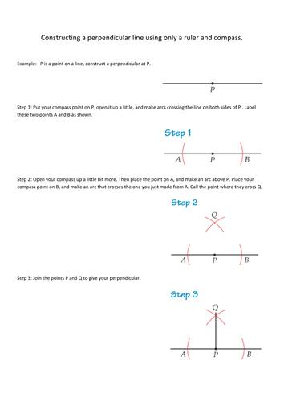
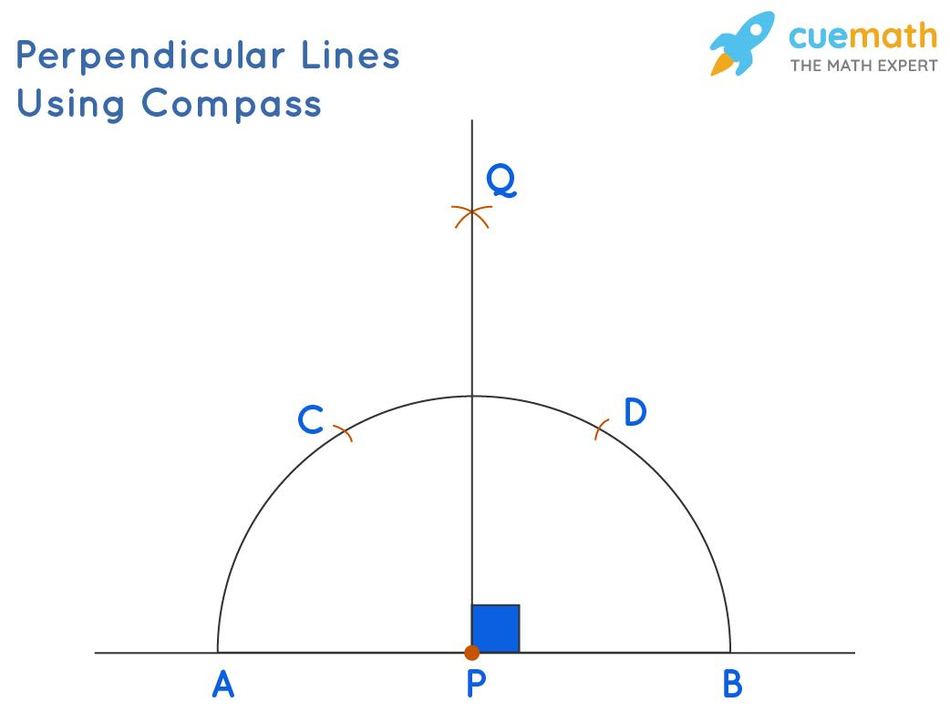

Fundamental Concept
# Source: AI Source: Provided by: [Data Path: Persons Table -> ID Column: 1, Name_En Column: Motasem Essam] -> From: [ChatGPT] on [7/25/2026]
The central property of perpendicular lines is:
$$\boxed{∠={90}^{∘}}$$
Therefore, constructing a perpendicular line is closely related to constructing a ${90}^{∘}$angle.
There are two fundamental classical constructions:
- Constructing a perpendicular through a point on a line
- Constructing a perpendicular through a point outside a line

1. Perpendicular Through a Point on a Line
# Source: AI Source: Provided by: [Data Path: Persons Table -> ID Column: 1, Name_En Column: Motasem Essam] -> From: [ChatGPT] on [7/25/2026]
Suppose $P$lies on the given line $l$.
The goal is to construct a line $m$such that:
$$P∈m$$
and:
$$\boxed{m⊥l}$$
Construction Steps
- Let $P$be the given point on line $l$.
- With the compass centered at $P$, draw an arc that intersects $l$at two points $A$and $B$.
- Using the same compass radius, draw an arc centered at $A$.
- Draw another arc centered at $B$with the same radius.
- Let the two arcs intersect at $Q$on one side of $l$.
- Draw the line through $P$and $Q$.
The resulting line satisfies:
$$\boxed{PQ⊥l}$$
The construction works because:
$$QA=QB$$
and:
$$PA=PB$$
Thus both $P$and $Q$are equidistant from $A$and $B$, so line $PQ$is the perpendicular bisector of $\overset{‾}{AB}$.

2. Perpendicular Through a Point Outside a Line
# Source: AI Source: Provided by: [Data Path: Persons Table -> ID Column: 1, Name_En Column: Motasem Essam] -> From: [ChatGPT] on [7/25/2026]
Suppose $P$is outside the given line $l$.
The goal is to construct a line through $P$perpendicular to $l$.
Construction Steps
- Let $P$be the point outside line $l$.
- With the compass centered at $P$, draw an arc large enough to intersect $l$at two points $A$and $B$.
- Using equal compass radii, draw arcs centered at $A$and $B$.
- Let the arcs intersect at $Q$on the side containing $P$.
- Draw the line through $P$and $Q$.
The resulting line is perpendicular to $l$:
$$\boxed{PQ⊥l}$$
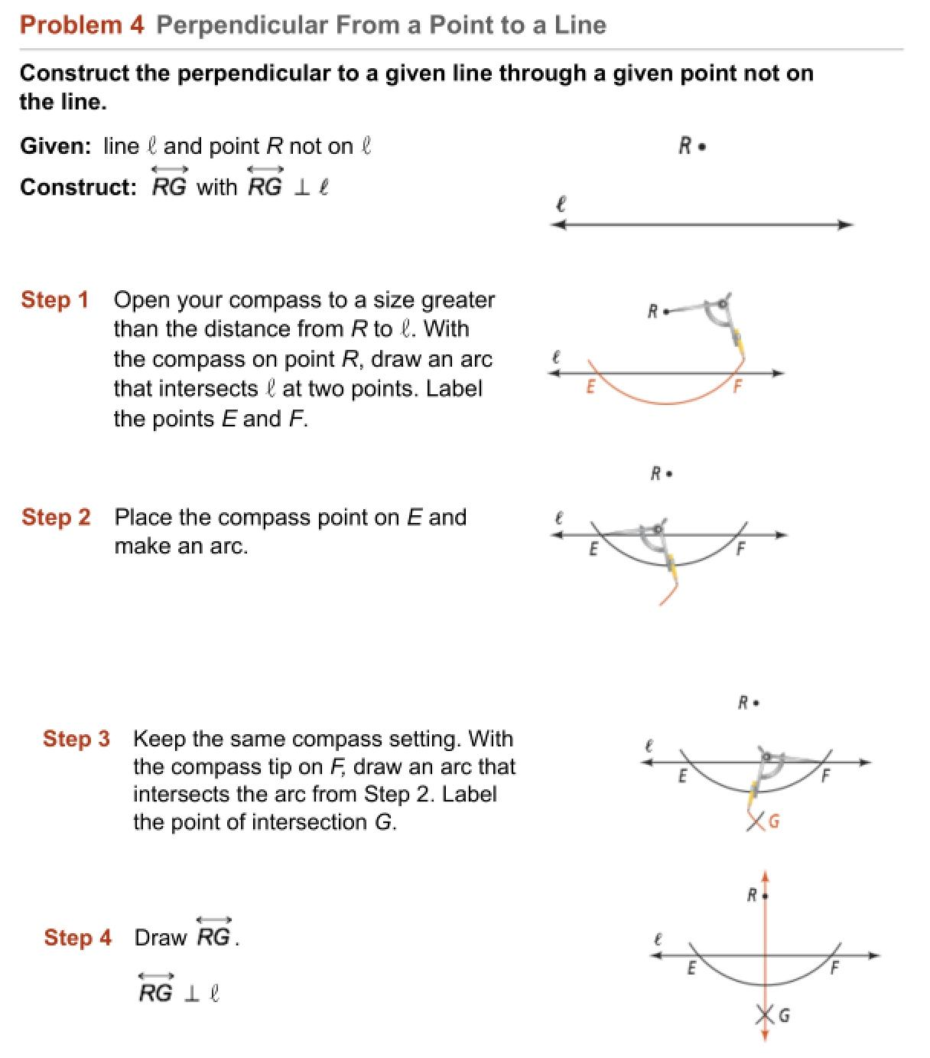

3. Constructing a Perpendicular Using a Perpendicular Bisector
# Source: AI Source: Provided by: [Data Path: Persons Table -> ID Column: 1, Name_En Column: Motasem Essam] -> From: [ChatGPT] on [7/25/2026]
A perpendicular line can also be constructed by using the perpendicular bisector of a segment.
If $A$and $B$lie on a line and:
$$M$$
is their midpoint, then the perpendicular bisector through $M$satisfies:
$$\boxed{AM=MB}$$
and:
$$\boxed{PM⊥AB}$$
Therefore, the perpendicular-bisector construction provides a direct method for constructing a perpendicular line.

4. Constructing a ${90}^{∘}$Angle
# Source: AI Source: Provided by: [Data Path: Persons Table -> ID Column: 1, Name_En Column: Motasem Essam] -> From: [ChatGPT] on [7/25/2026]
A perpendicular line can also be viewed as constructing a ${90}^{∘}$angle.
If:
$$l_{1}⊥l_{2}$$
then:
$$\boxed{∠\left(l_{1} , l_{2}\right)={90}^{∘}}$$
Therefore:
$$\boxed{\text{Constructing a Perpendicular Line }⟺\text{ Constructing a Right Angle}}$$
in the geometric sense.

Coordinate Relationship
# Source: AI Source: Provided by: [Data Path: Persons Table -> ID Column: 1, Name_En Column: Motasem Essam] -> From: [ChatGPT] on [7/25/2026]
For non-vertical lines, if the slope of the given line is:
$$m_{1}$$
then the slope of a perpendicular line is:
$$\boxed{m_{2}=-\frac{1}{m_{1}}}$$
Therefore:
$$\boxed{m_{1}m_{2}=-1}$$
For example, if:
$$m_{1}=2$$
then:
$$m_{2}=-\frac{1}{2}$$
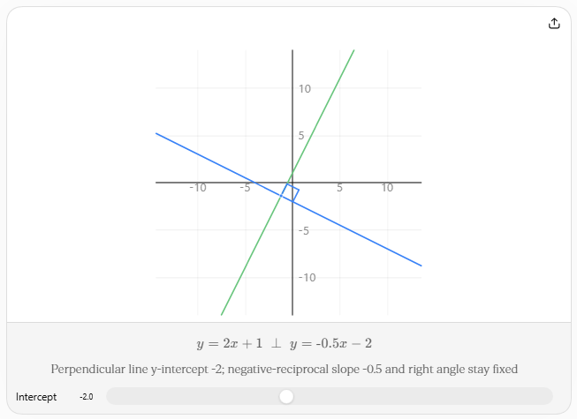
Special Cases
If the given line is horizontal:
$$y=c$$
its perpendicular is vertical:
$$\boxed{x=d}$$
If the given line is vertical:
$$x=c$$
its perpendicular is horizontal:
$$\boxed{y=d}$$

Main Characteristics
# Source: AI Source: Provided by: [Data Path: Persons Table -> ID Column: 1, Name_En Column: Motasem Essam] -> From: [ChatGPT] on [7/25/2026]
Property | Constructing a Perpendicular Line
Main object | Line
Required relationship | Perpendicularity
Intersection angle | $${90}^{∘}$$
Classical tools | Straightedge and compass
Can pass through a point on the line | Yes
Can pass through a point outside the line | Yes
Related construction | Perpendicular bisector
Related angle | Right angle

Relationship to Other Constructions
# Source: AI Source: Provided by: [Data Path: Persons Table -> ID Column: 1, Name_En Column: Motasem Essam] -> From: [ChatGPT] on [7/25/2026]
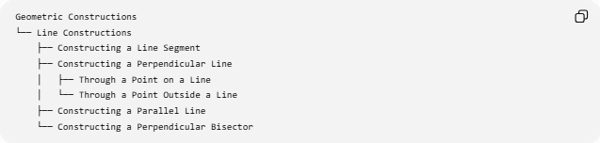
Geometric Constructions
└── Line Constructions
├── Constructing a Line Segment
├── Constructing a Perpendicular Line
│ ├── Through a Point on a Line
│ └── Through a Point Outside a Line
├── Constructing a Parallel Line
└── Constructing a Perpendicular Bisector
The perpendicular construction is also closely related to:
- ${90}^{∘}$angle construction
- Perpendicular bisectors
- Angle bisectors
- Parallel-line constructions
- Triangle constructions

Perpendicular Line vs Perpendicular Bisector
# Source: AI Source: Provided by: [Data Path: Persons Table -> ID Column: 1, Name_En Column: Motasem Essam] -> From: [ChatGPT] on [7/25/2026]
These terms should not be treated as identical.
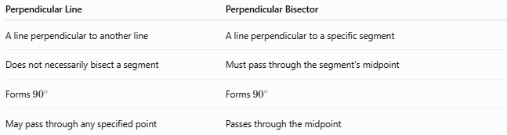
Perpendicular Line | Perpendicular Bisector
A line perpendicular to another line | A line perpendicular to a specific segment
Does not necessarily bisect a segment | Must pass through the segment's midpoint
Forms ${90}^{∘}$ | Forms ${90}^{∘}$
May pass through any specified point | Passes through the midpoint
For a perpendicular bisector of $\overset{‾}{AB}$:
$$\boxed{AM=MB}$$
and:
$$\boxed{PM⊥AB}$$
Thus, every perpendicular bisector is a perpendicular line, but not every perpendicular line is a perpendicular bisector.

Classification
# Source: AI Source: Provided by: [Data Path: Persons Table -> ID Column: 1, Name_En Column: Motasem Essam] -> From: [ChatGPT] on [7/25/2026]
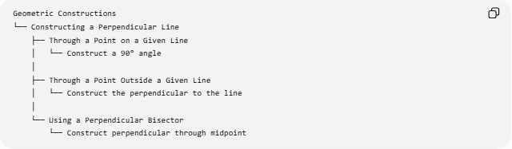
Geometric Constructions
└── Constructing a Perpendicular Line
├── Through a Point on a Given Line
│ └── Construct a 90° angle
│
├── Through a Point Outside a Given Line
│ └── Construct the perpendicular to the line
│
└── Using a Perpendicular Bisector
└── Construct perpendicular through midpoint

Key Formulas and Relationships
# Source: AI Source: Provided by: [Data Path: Persons Table -> ID Column: 1, Name_En Column: Motasem Essam] -> From: [ChatGPT] on [7/25/2026]
Perpendicularity
$$\boxed{l_{1}⊥l_{2}}$$
Right Angle
$$\boxed{∠\left(l_{1} , l_{2}\right)={90}^{∘}}$$
Slopes
$$\boxed{m_{1}m_{2}=-1}$$
for non-vertical, non-horizontal lines.
Perpendicular Bisector
$$\boxed{AM=MB} \\ \boxed{PM⊥AB}$$

Key Points
# Source: AI Source: Provided by: [Data Path: Persons Table -> ID Column: 1, Name_En Column: Motasem Essam] -> From: [ChatGPT] on [7/25/2026]
- A perpendicular line intersects another line at ${90}^{∘}$.
- The symbol for perpendicularity is:
$$\boxed{⊥}$$
- A perpendicular can be constructed through a point on a line.
- A perpendicular can also be constructed through a point outside a line.
- The construction uses equal-radius compass arcs and a straightedge.
- A perpendicular bisector is a special perpendicular line that also passes through the midpoint of a segment.
- In coordinate geometry, perpendicular non-vertical lines have slopes whose product is $-1$.

Conclusion
# Source: AI Source: Provided by: [Data Path: Persons Table -> ID Column: 1, Name_En Column: Motasem Essam] -> From: [ChatGPT] on [7/25/2026]
Constructing a Perpendicular Line is a fundamental geometric construction used to create a line that intersects a given line at exactly ${90}^{∘}$.
The central relationship is:
$$\boxed{\text{Perpendicular Lines}→{90}^{∘}}$$
and, for non-vertical coordinate lines:
$$\boxed{m_{1}m_{2}=-1}$$
The two principal constructions are a perpendicular through a point on a line and a perpendicular through a point outside a line.

